**Low Loss, High Isolation**

**SP6T Wideband RF Switch**

**Suitable For 5MHz to 3000MHz**

**Frequency Range**



**By:**

Aditya Mukherjee

Subham Kundu

**Under the guidance of:**

Malay Gangopadhyay

Kaushik Patra

Rintu Kumar Gayen

Kuntal Bhattacharya

Tutai Kumar Dalal

*January 2020*

**SP6T Wideband RF Switch**

**(Single Pole Six (6) Throw)**

**Wireless Addon | Modular | ASUS Tinker Board** **v0.1**

**50Ω 5 to 3000 MHz 1 x 6 (RFSW6062)**

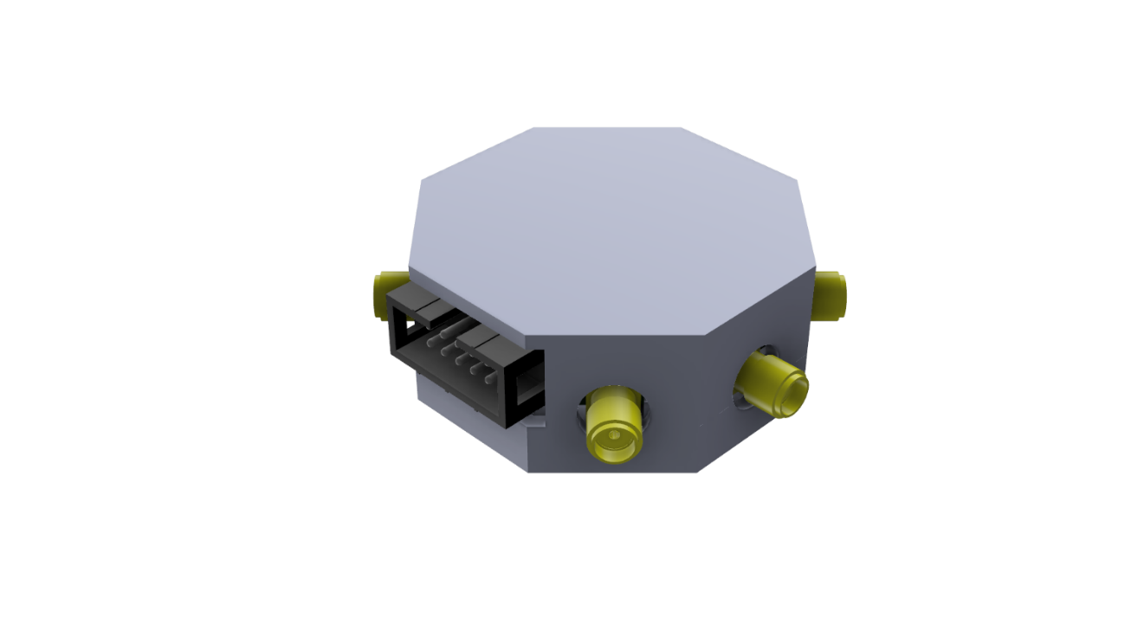

**FEATURES:**

* **5 MHz to 3000 MHz operation**
* **Excellent insertion loss and isolation performance**
* **Compatible with 3.3V logic**
* **No DC blocking**
* **2000V HBM ESD Rating on All Ports**
* **3V to 5V operation**
* **Low power device (≈100µA current draw)**

FRC Connector SMA Port

**Note:** The FRC cable must be connected such that the notch in the FRC plug lines up with the notch in the socket on the RF switch board and the notch on the other plug must fall on the outside edge of the Tinker board.

**Block Diagram:**

**CTL pins are tolerant up to 3.3V not 5V.**

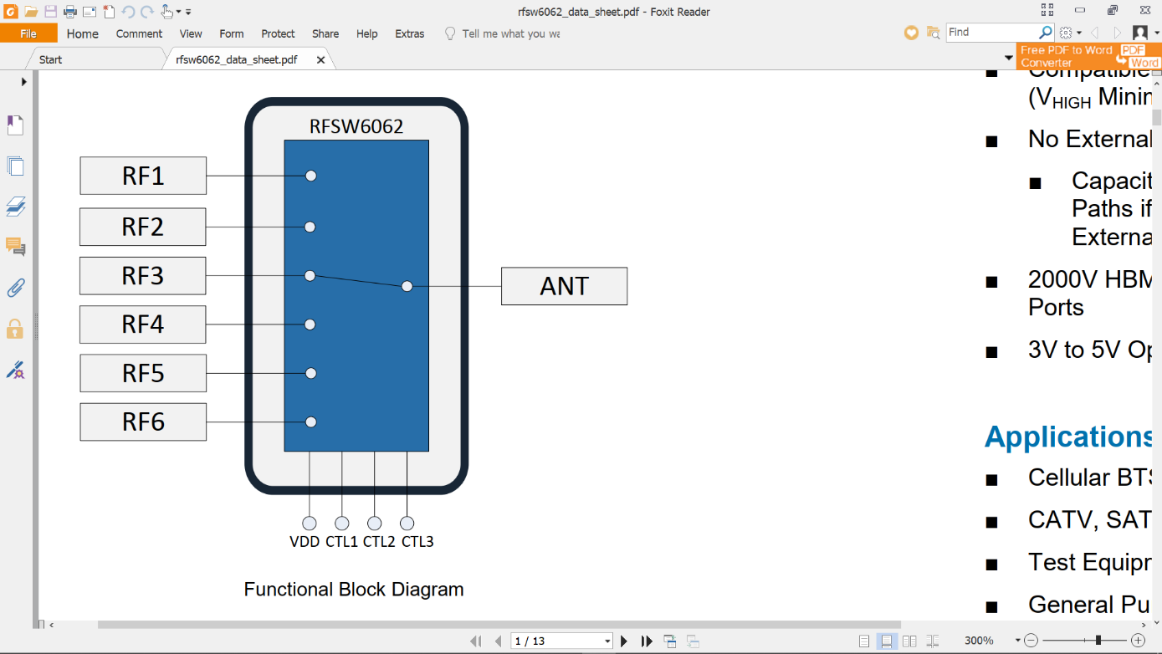RF_COM is connected to any one of RF1-6 at a time. The connection is configured using a 3-bit control logic using CTL1, CTL2 & CTL3.

**RF_COM**

|  |  |  |  |
| --- | --- | --- | --- |
| CTL3 | CTL2 | CTL1 | MODE |
| 0 | **0** | **0** | **ALL OFF** |
| 0 | **0** | **1** | **RF1** |
| 0 | **1** | **0** | **RF2** |
| 0 | **1** | **1** | **RF3** |
| 1 | **0** | **0** | **RF4** |
| 1 | **0** | **1** | **RF5** |
| 1 | **1** | **0** | **RF6** |

**For technical support contact** [**adityam545@gmail.com**](mailto:adityam545@gmail.com)

**PINOUT:**

|  |  |  |
| --- | --- | --- |
| **PIN FUNCTIONS** | | |
| **PIN** | **NAME** | **FUNCTION** |
| **1** | **NC** | **Not Connected** |
| **2** | **VCC (5V)** | **Power Supply** |
| **3** | **NC** | **Not Connected** |
| **4** | **VCC (5V)** | **Power Supply** |
| **5** | **NC** | **Not Connected** |
| **6** | **GND** | **Ground** |
| **7** | **CTL_3** | **Switch Control Logic 3** |
| **8** | **CTL_2** | **Switch Control Logic 2** |
| **9** | **GND** | **Ground** |
| **10** | **CTL_1** | **Switch Control Logic 1** |

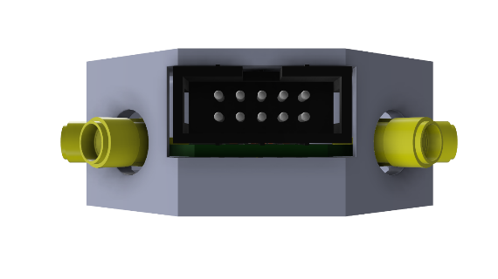

|  |  |
| --- | --- |
| **NC** | **VCC (5V)** |
| **NC** | **VCC (5V)** |
| **NC** | **GND** |
| **CTL_3** | **CTL_2** |
| **GND** | **CTL_1** |

**NOTCH**

**Pins Used On The Tinker Board:**

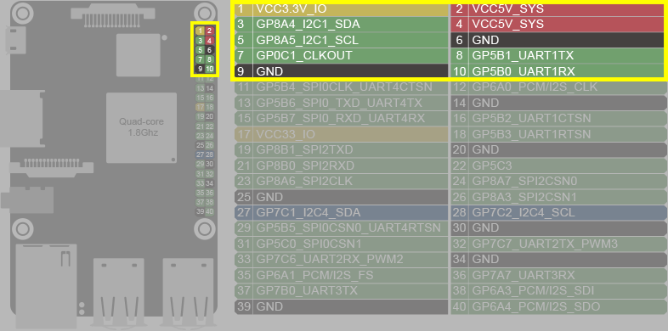

**NOTCH SIDE**

|  |  |
| --- | --- |
| CTL_1 | wPi 16 |
| CTL_2 | **wPi 15** |
| CTL_3 | **wPi 7** |

**wiringPi**

**Pin Numbers:**

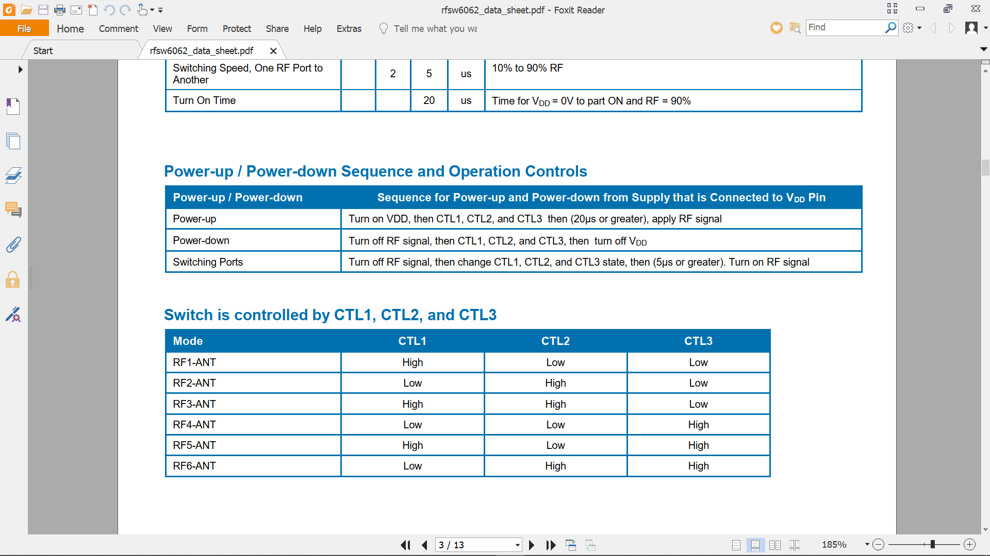

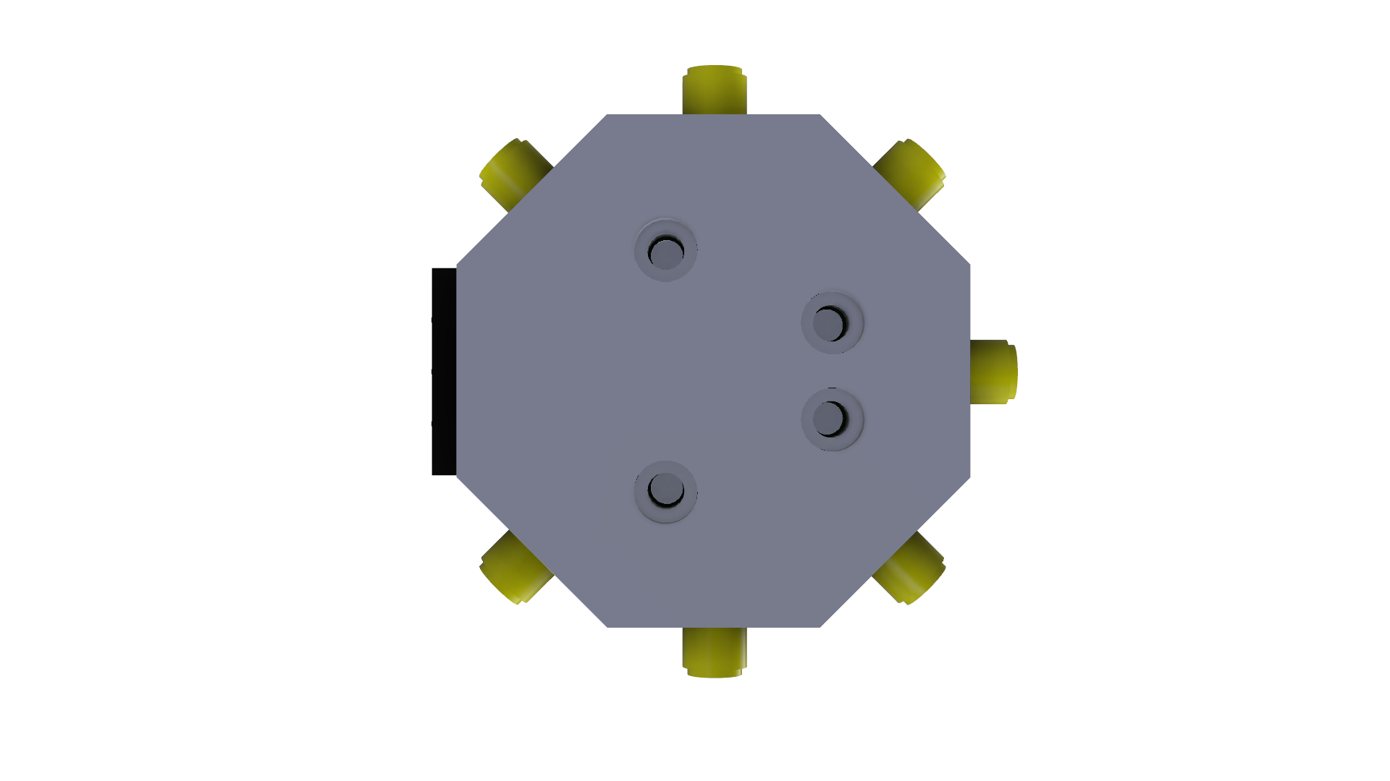**Port Mapping:**

This port mapping is done with the screw face on top. If you are viewing with the other face on top, the mapping will change.

**RF_5**

**RF_6 RF_7**

**M3 Screws RF_COMM**

**FRC Port**

**RF_3 RF_1**

**RF_2**

**RF Parameters (2.45GHz):**

1. Average reflected power **from selected port** or **RF_COMM** = **-11dB** => **0.08 x P(in).**

**P(in)**

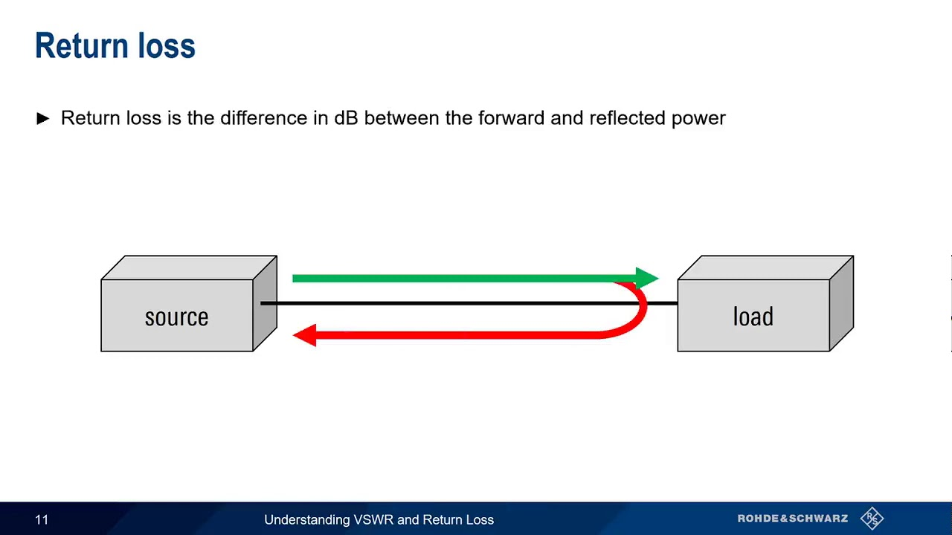

**0.08x P(in) gets reflected back**

1. Avg insertion loss (**IL**)incl coaxial loss = **1.6dB** =>  **0.7xP(in)** gets transmitted.
2. Avg insertion loss (**IL**)excl coaxial loss = **0.5dB** => **0.9xP(in)** gets transmitted.

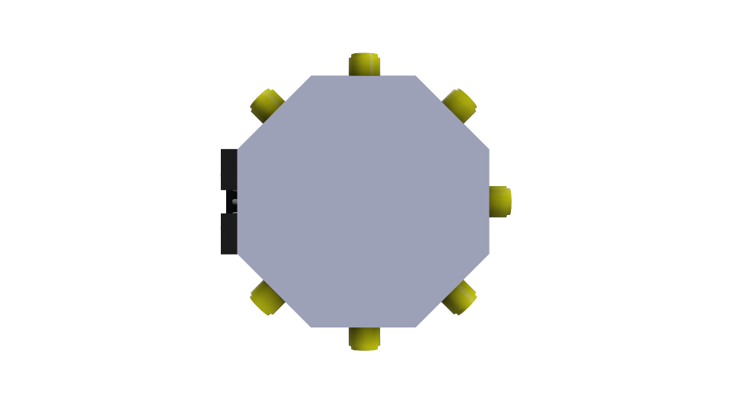

**0.9 x P(in)**

**P(in)**

1. Average isolation between selected port and other ports = **26dB** =>  **0.002 x P(in)**

The power level of the leaked or coupled signal on the unselected ports is as low as 0.002 times (or -26dB) the power level on the selected port.

Coupled (leaked) signal

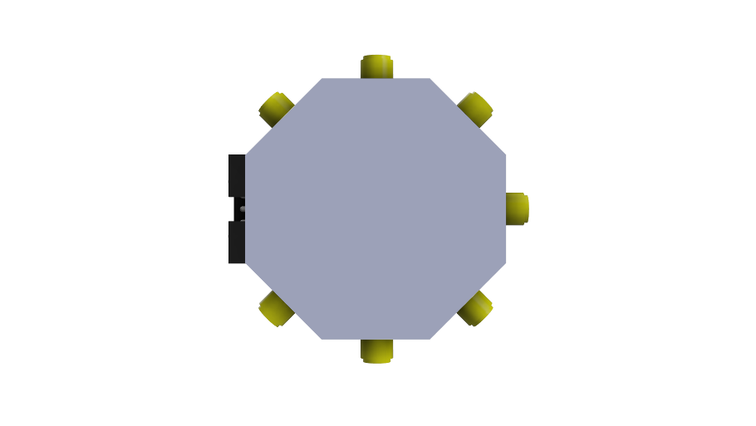 **0.002 x P(in)**

Similarly, for all unselected ports **0.9 x P(in)**

**P(in)**

**Connecting the Tinker Board:**

* 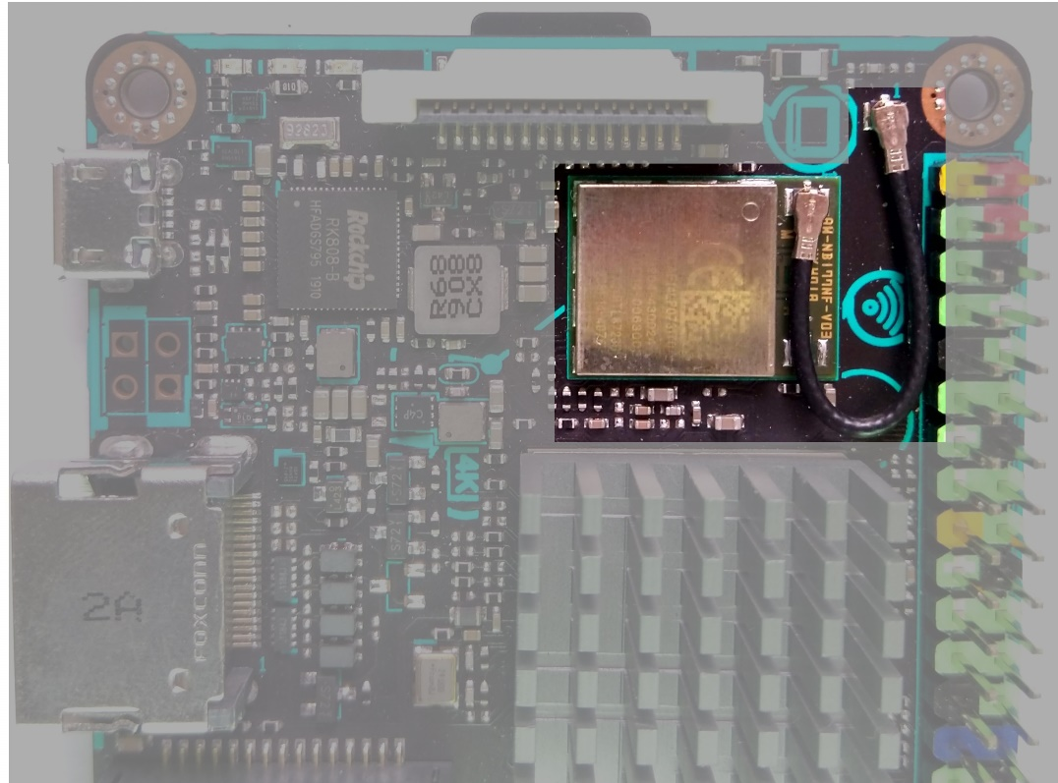Locate the green RF module and the short IPEX coaxial connector connecting it with the on-board antenna.
* Carefully unplug both ends using a pair of tweezers.
* Connect the male-male SMA connector with the IPEX-SMA cable.

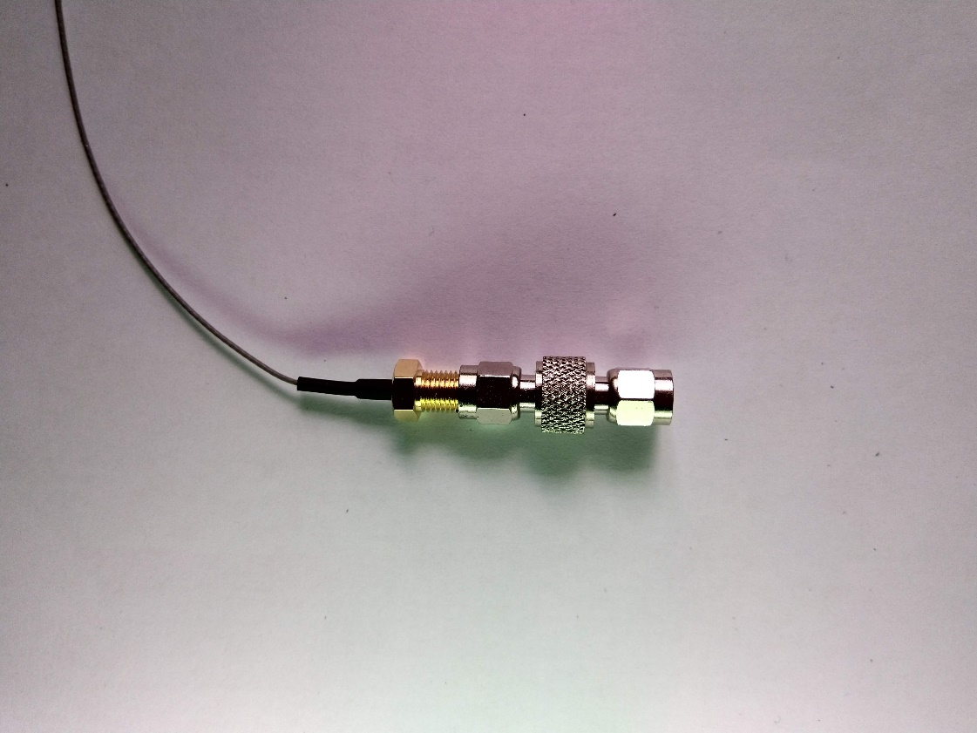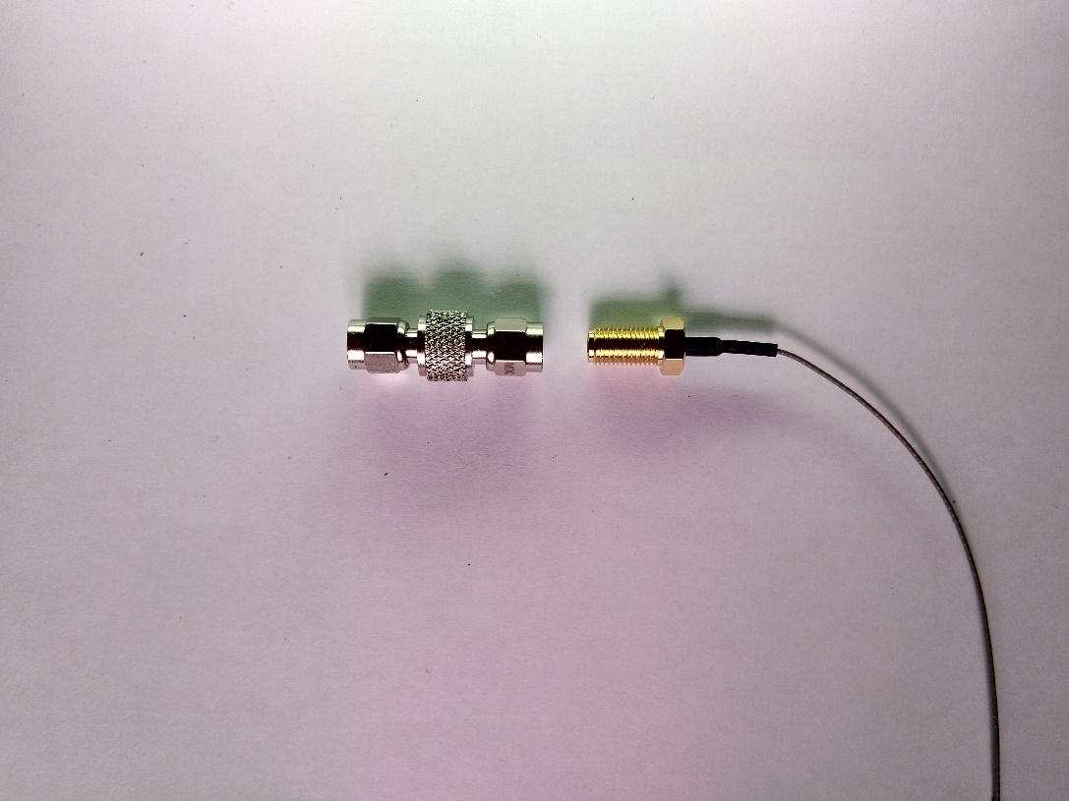

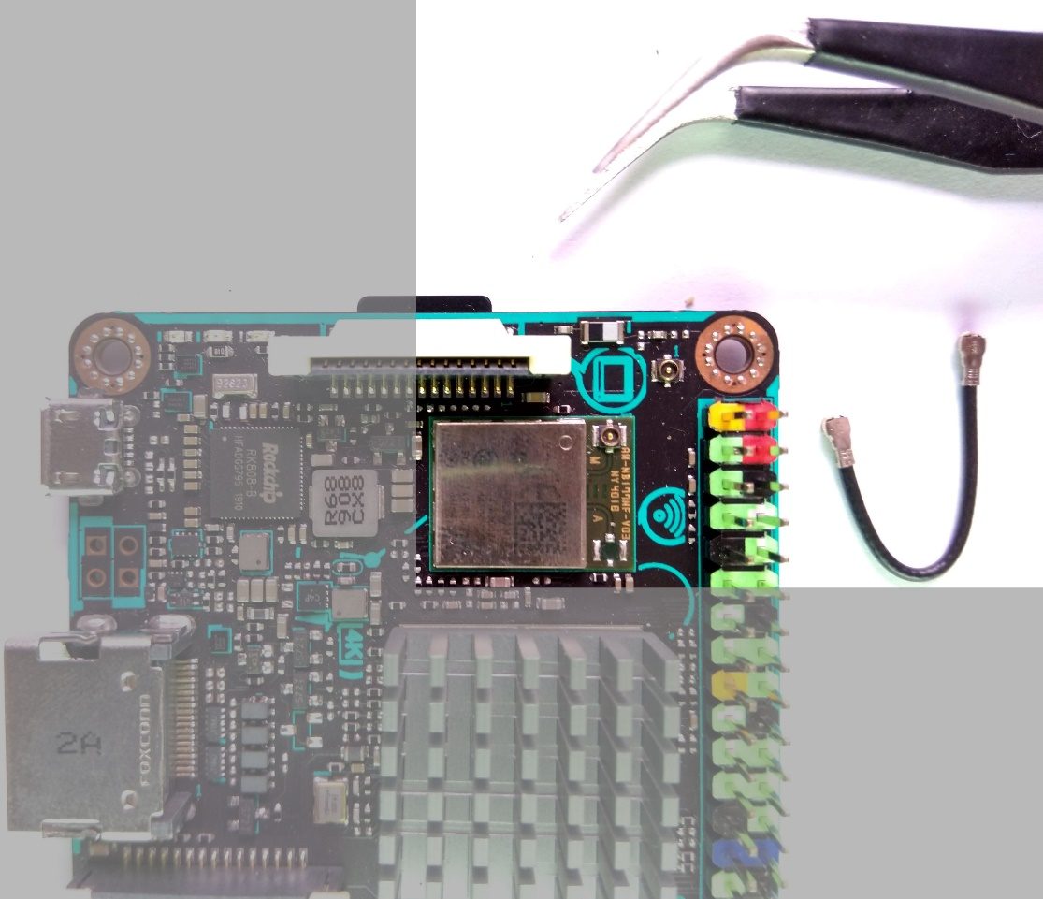

**IPEX-SMA Cable**

**Male-Male SMA**

* Connect the IPEX port of the IPEX-SMA cable to the IPEX port on the green RF board (not the IPEX port of the on board antenna) by lining it up carefully and pressing it down with your nails or a small hard surface like the end of toothpick till you feel a “click/snap”. Check the connection by gently applying tension on the cable.

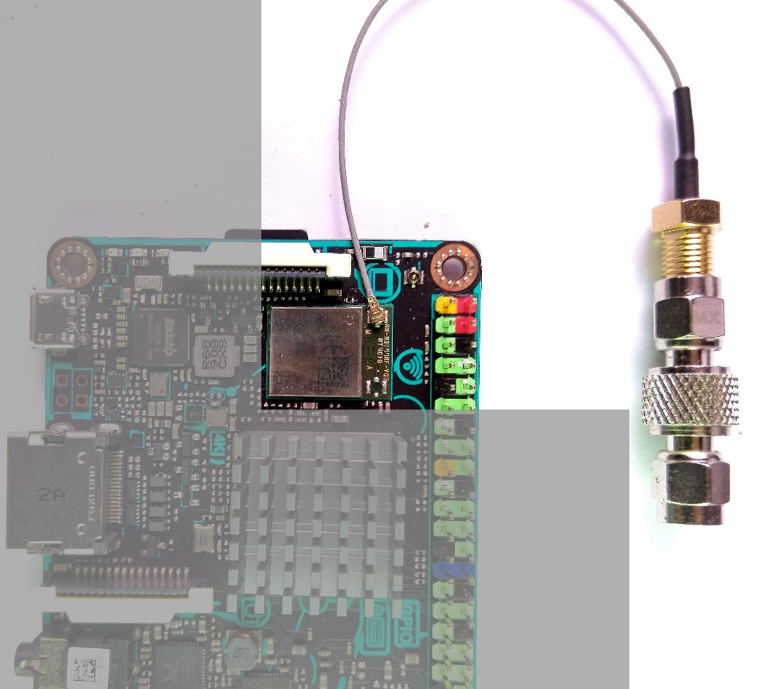

IPEX port of on-board antenna

* Connect the RF switch’s RF_COMM port with the other end of the cable (SMA Male).

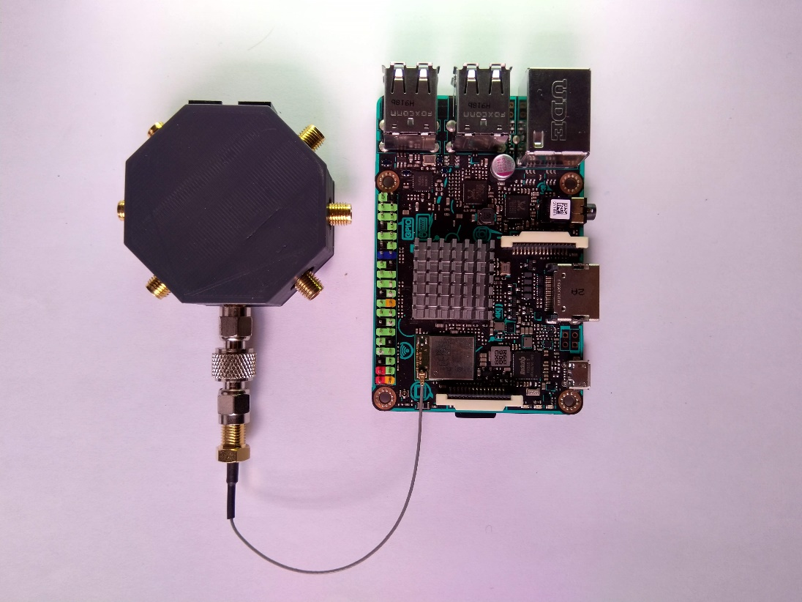

* Plug in the female header side of the FRC to female header converter on the tinker board male pins starting from pin 1. Also, keep the notch of the FRC box socket on the outside (as shown in the diagram).

Pin 1

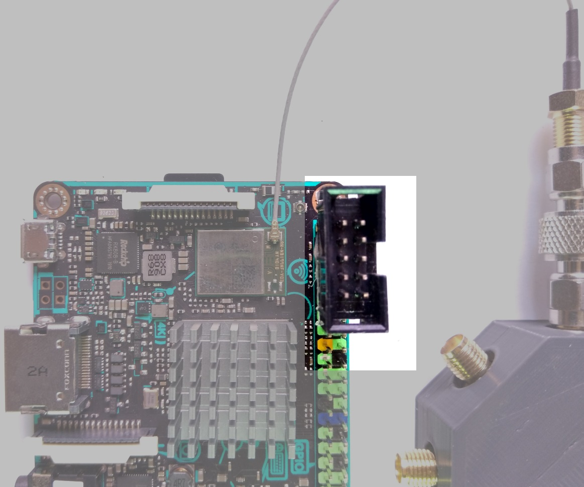 NOTCH

* Get 10 pin FRC cable and make sure that the notches on both ends line up on the same side.

NOTCH

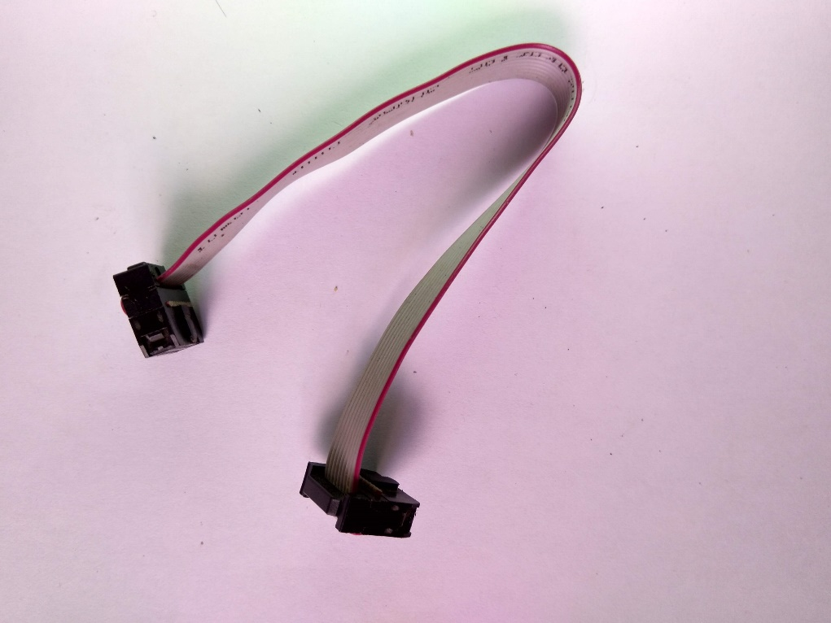

* Finally connect the RF switch and the tinker board with the FRC cable, again paying attention to the notch (we’ve had enough of the notch!).

